Ludum Dare 52 Game Design Document

Game Title: Disassembly Line  
Characteristics: Cutesy, High Energy, Tongue-In-Cheek Horror Harvest

Schedule

Friday:

* Theme

* MVP Plan

* Baseline Mechanic

* TBD Name

Saturday

* Vertical Slice

Sunday

* Feature Complete (expand or cut)

* Polish

Monday

* More Polish

Game Loop

Start Screen

* Intro boring farm sim
* Scroll down to mad lab

Level

* Entrance for bodies
* Organ submission
  + Limit what you can submit
  + “Dr Frankenstein” type character yelling for ingredients
* Misc. additions to make easier/harder (AC?)
* Rage timer once enraged the player is killed transition to end screen

End Screen

* Summary of Score/Parts
* Ask the player if they wanna play again

Assets

Art

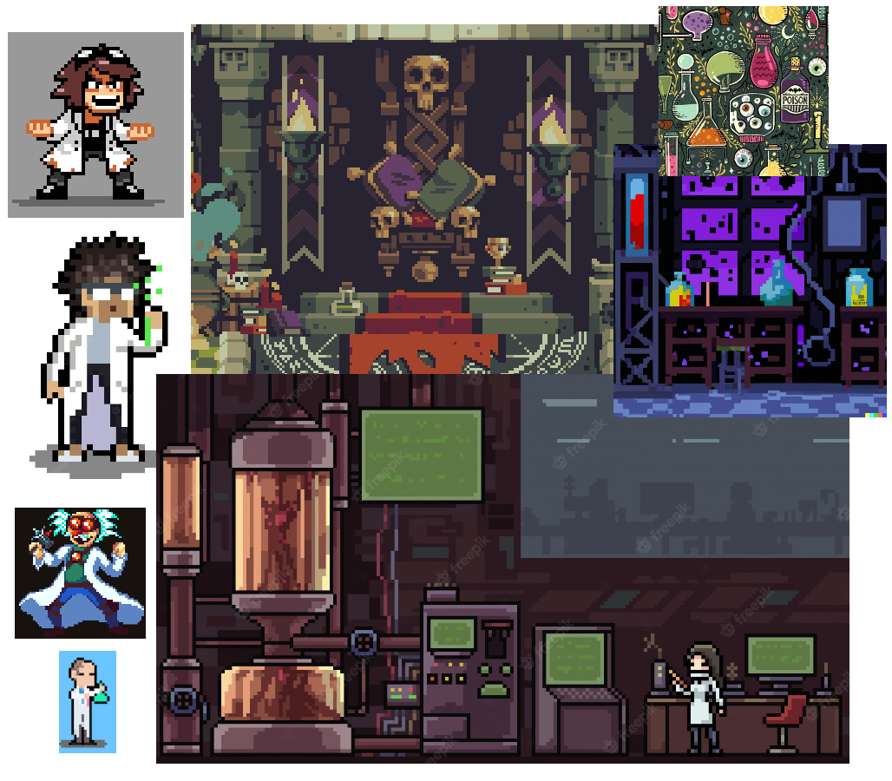

* Background image for the room

Should be a dingy sort of lab. Should have the tools workbench and the

bases of the conveyor belts they are static images

* Body(A couple types if we have time)

Kind of dead looking (blue)? maybe smiling or something silly

* Grinder(for body disposal)

Metal hood that goes on the end of the conveyor belts has a shaking

animation for when the bodies are being grinded

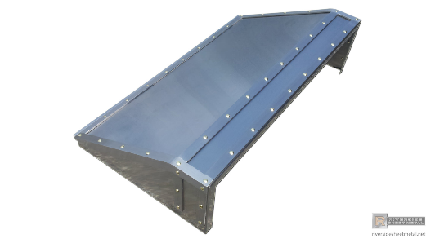

* Organs (Heart, brain, lungs, leg) In colors that match tools 32x32

* Tools( Saw, scoop, Drill, scalpel) In colors that match Organs 32x32



* Air conditioner

* Top of the Conveyor belt animated

This can probably be one animated tile that makes it look like the tile is

moving sort of how pixelated water animations are done.

* Rage timer of some sort to display
* Start menu and End screen( Selecting a font and menu options)
* Entrance door for bodies

Player character and animations

Player is a lab assistant that is in constant danger of getting his organs harvested themselves. Should look cutesy lab assistant. Maybe some blood on the coat?

* Walk
* Working on body (facing camera and away from camera)
* Fixing equipment (Facing away from the camera)
* Picking up organ(left hand)
* Dropping organ into hole
* Picking up tool (right hand)
* Putting down tool
* ?Holding each tool and organ (this could be as simple as putting a generic hand full sprite on the player, not sure) Maybe we can do this programmatically?

If we have time

* Dr who is making frankenstein that yells HEY I'M WORKING HERE

**Game Sprites Order in Layer**

* Level  = -100
* Player = 0
* Dead Bodies = 1
* Organ = 1

Sounds

* ~~Full OST~~ One song
* Sound Effects
  + Footsteps
  + Tools
    - Saw
    - Scoop
    - Drill
    - Scalpel
  + Dash
  + AC (bang, broken)
  + Squishy sounds
  + Angry guy sounds
  + Rage meter increase
  + Grinder
  + Error sounds

Game Mechanics

* Input (Movement, Dash (with cool off), Click (Interact))
* Spawning random bodies with organs.
* Conveyor Belt.
* Game manager.
* InteractableObject interaction
  + Interactable objects
    - Dead Body
    - AC
    - Conveyor belt
    - Fuse box
    - Tools

* Carry organ by player
* Rage meter
  + If an organ is grinded the rage goes up
  + If the rage goes to max the game ends and the player is harvested
  + Gross sound and a scream? Fade to black Load game over/Score screen
* Random breaking of interactable objects e.g ac, fusebox, etc
  + Fuse box
    - If the fuse box breaks everything goes dark except for the player and the fuse box
    - The player then has to go to the fuse box and repair it to turn the lights back on
  + Air conditioner
    - If the air conditioner breaks the decay rate on the organs increases.
    - The player has to go to the Air conditioner to repair it.
* Harvest organ
  + Organs have decay rate,
  + The sooner a player harvests an organ and deposits it the more points it's worth
  + Once an organ has decayed it is worth 0 points but it can still be harvested to avoid adding rage
  + If an organ is grinded up it adds rage
* Event System ( events )
  + RaiseHarvestToolErrorEvent: When using wrong tool for harvesting an organ.
  + OnOrganGrindedEvent.
  + RaiseBodyGrindedEvent
  + RaiseUpdateRageMeterEvent
  + Game over
  + Game start
  + Breaking of stuff
  + RaiseOnConveyorBeltMotionPauseEvent: Pausing Conveyorbelt
  + RaiseOnConveyorBeltMotionResumeEvent: Resuming conveyor belt
  + RaiseOnCBUpdateSpeedEvent
  + OnDecayRateUpdateEvent

     Holding objects, one tool(right hand) and one organ(left hand).

     Dr frank random behaviour.(Add-on)

|  |  |  |  |
| --- | --- | --- | --- |
|  | Tool | Organ | HarvestTime |
| 1 | Drill | Brain | 4 |
| 2 | Scoop | Lungs | 3 |
| 3 | Saw | Legs | 2 |
| 4 | Scalpel | Heart | 1 |

|  |  |  |  |
| --- | --- | --- | --- |
|  | Organ | Decay rate | Score |
| 1 | Heart | 40 | 4 |
| 2 | Legs | 30 | 3 |
| 3 | Brain | 25 | 5 |
| 4 | Lungs | 25 | 4 |

|  |  |  |
| --- | --- | --- |
|  | Object | FixTime |
| 1 | AC | 3 |
| 2 | COnvyor belt | 3 |
| 3 | Fuse box | 3 |

Alternate Game Ideas

* Grim Graveyard Puzzle Game (Traffic jam)
* River styx momentum game
* Physics based harvest game
* Meta idea brent
* Operation/greys anatomy scary maze organ harvesting
* Collecting/harvesting top down
* Something with summons
* Foraging (don’t starve?)
* Playing as plants (any mechanic) fighting off harvest
* Corn field maze
* Reapers/matrix - population harvest
* Physics based saw blade cutter
* Crop circles? Aliens?
* Rampage tornado
* Bionic commando space swinger
* Tapper body organ harvesting